Problem Chosen
F
2020  MCM/ICM  Summary Sheet | Team Control Number  2020016

Models Analyzing How Climate Refugees are Resettled
Summary
Global warming has reduced the land area of some island nations year by year, which led to environmentally displaced persons (EDPs) that have brought about a series of issues such as their human rights and culture in their new homes. We select several major immig-ration countries in the world, analyze the plight of refugees due to incomplete policies, pro-posed measures accordingly, and establish a simple Bayesian network to provide preliminary solutions to it.
First, we establish two models to study the growing trend of climate EDPs and the risk of EDP culture loss this year. The number of EDPs is positively correlated with sea level rise, but the trend of sea level rise is difficult to predict accurately and intuitively. Therefore, we first establish a regression model to simulate the relationship between sea temperature and sea level rise, on which we predict the number of future EDPs by the sea level rise. The re-sults show that, a slight increase in temperature can cause a large number of new EDPs to accumulate over time, under the influence by the number of refugees already in existence.
In order to measure the risk of cultural loss, we search for several relevant factors. The se-cond model uses several vital factors analyzed as the determining conditions. The weights constructed by its hierarchical analysis are discussed on the basis of the situation in the United States, Germany and the other 4 countries. Thus we get a relative risk, by which we can evaluate the relative cultural risk of immigrants using the data of specific regions.
Following the analysis of climate EDP policies in various countries, we make specific sug-gestions on human rights and cultural aspects of EDPs. The third model is an input-output prediction model built on Bayesian network. It gives us a precise impact that the implemen-tation of the policy can increase our indexes by about 3%. To make it more real, we add op-timization schemes that affect the number of EDPs on each node of the network. But the disadvantage is that there is only a relative improvement number and lack of specific data characterization.
Finally, we conduct an analysis of policy necessity, sensitivity analysis of the model.

Key words: EDPs;regression model; hierarchical analysis; Bayesian network; policy
Contents
1 Introduction 1
1.1 Background 1
1.2 Restatement of the Problem 1
2 Assumptions and Notations 1
2.1 Assumptions 1
2.2 Notations 2
3 Model Construction 2
3.1 Risk Population Estimation Model 2
3.2 Cultural Loss Risk Assessment Model 4
4 Policy Analysis Model 7
4.1 Proposed Policy 7
4.1.1 Human Rights 7
4.1.2 Cultural Protection 8
4.2 Model Construction of Potential Impact of Policies 9
4.3 Model Optimization 14
4.4 The Importance of Policy 16
4.4.1 Human Rights 16
4.4.2 Cultural Protection 17
4.4.3 EDP-Receiving Country 18
4.5 Sensitivity Test 19
4.6 Strengths and Weaknesses 19
References: 20

1 Introduction
1.1 Background
As sea levels rise, Maldives, Tuvalu, Kiribati, and The Marshall Islands face a reduction in the size of the country and the risk of people becoming EDPs. The migration and resettlement of EDPs will often cause a whole new set of problems, from the right of EDPs, the demand in the new country, to the cultural maintenance of the entire refugee group. However, there is not much research in related fields, and some data predictions even differ by 10 to 20 years. This will inevitably lead to inaccuracy of the United Nations solution to refugee problems.
At the same time, the receiving countries have different policies on EDP issues. Many inappropriate measures have had a bad impact on the country already, such as squeezing resources and increasing refugee crime rates. A model is urgently needed that measures the seriousness of the EDP problem and can adjust the policy to the specific circumstances of the country.

1.2 Restatement of the Problem
- Establish models to assess the number of EDPs and their risk of cultural loss.
- Propose specific polices that can be adopted by the state to safeguard the human rights and culture of EDPs.
- Use the new model to predict how effective the proposed policy will be and what limitations.
- Considering the inevitable differences caused by the acceptance of national conditions, the model should be modified to achieve the purpose of improving the universality of the model.

2 Assumptions and Notations
2.1 Assumptions
To simplify our problems, we make the following basic assumptions, each of which is properly justified.
- Assume that global warming is irreversible, that is, human measures and activities will not affect sea level rise.
- Assume that countries that meet the acceptance criteria will accept EDPs.

- The following model is built for climate refugees only.

2.2 Notations

Table1. Symbols used
Symbolic | Description
T | Global mean temperature
SL | Sea level
T_{S} | Increase of global mean temperature
a, k, δ | Coefficient of regression 1
R² | Goodness of fit of the model
n_{i} | Amount of new EDPs in year i
N_{i} | Amount of total EDPs from year 1 to year i
p₁, p₂, q₁ | Coefficient of regression 2
NP | national policy strictness index
CC | Culture conflict index
NM | Number of Migrants
RM | Relative density of migrants
A | Paired comparison matrix to measure the weights of NP, CC, NM and RM.
HR | Human right index
CP | Culture protection index
Q | Matrix containing probabilities of situations while single policy works on the problem
i_{j} | Completeness of policy j
ρ, σ, τ | Good, moderate and poor probabilities while combination of policies work(s) on the problem
P_{Hi}, P_{Ci} | Excellence probabilities of HR and CP

3 Model Construction
3.1 Risk Population Estimation Model

In order to predict the changing trend of the number of at-risk refugees, we found the main cause of the risk, that is, sea level rise, which in turn is caused by warming and rising tempe-ratures. First we try to find a simple regression relationship between temperature T and sea level SL.
In the short term, sea level rise is approximately linear with the global average temperature. To determine the slight error that may be brought about in the index, we use a regression mo-del to approximate the changes of SL and T within 11 years.
It should be noted that the global average temperature is affected by the terrestrial climate, so it fluctuates periodically and does not always rise uniformly. And sea level is only related to ocean temperature. In 11 years, it covers about three temperature periods. The larger the temperature value, the larger the error. Therefore, we need to choose a regression model with stability so as to simulate the relationship between the two as best as possible.
The model 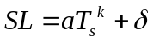 can well meet our requirements.
After simulation, the parameter data is obtained: a = 184.5, k = 0.4975, δ = -87.17, the image is very close to a straight line, which meets the simulation requirements; the goodness of fit R² = 0.8423, which meets the error requirements.

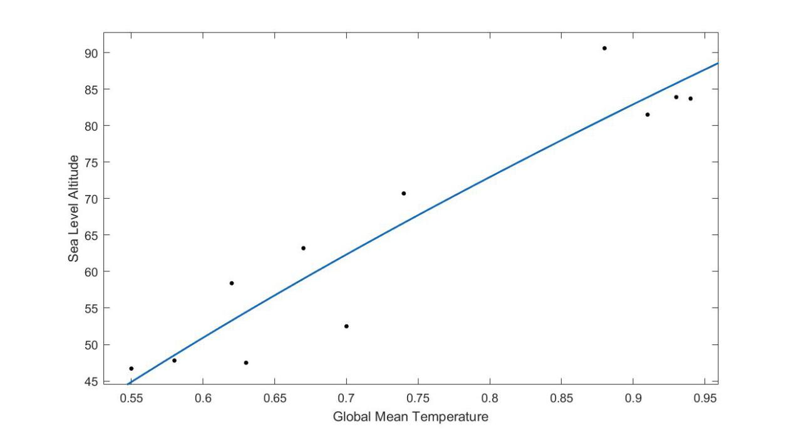
Figure1. Sea level altitude vs. Global mean temperature
The next step is to count the number of EDPs. As the number of EDPs is the result of the accumulation effect of sea level rise, we need to first add the number of new EDPs, that is, N_{i} = N_{i-1} + n_{i} is obtained from each year of new EDPs.

The initial 2008 is the benchmark, which means

N₁ = n₁.

To determine how the number of EDPs varies with SL, we consider the following possible regression fitting methods.

Rational return：

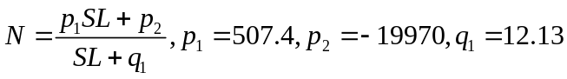

Goodness of fit: R²=0.8969.

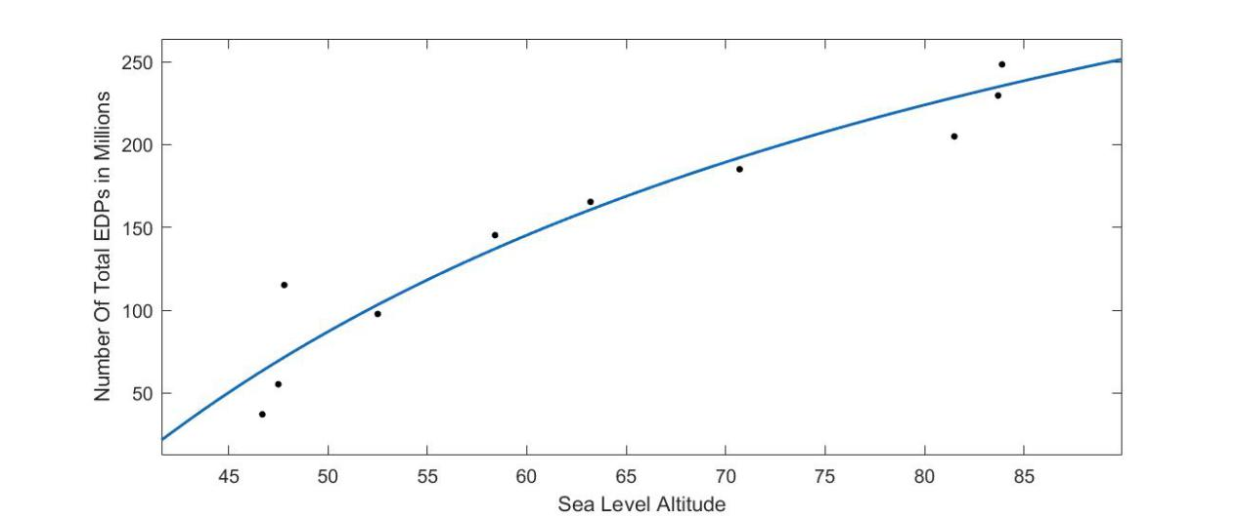
Figure2. Number of total EDPs in years vs. sea level altitude
The two types of integration can obtain the total number of EDPs from the change in temperature (regardless of the temperature drop), and subtracting N11 is the number of EDPs at risk at that temperature.

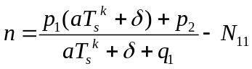

Assuming that the temperature in the new year reaches 0.94, the calculated number of new refugees will reach 10.44 million. According to the temperature cycle in the image, the time is on the rise, so the number of people we get is slightly less than ideal.
3.2 Cultural Loss Risk Assessment Model

Regarding the risk of cultural loss, combined with the actual situation, by consulting the information, we sort out the following factors:

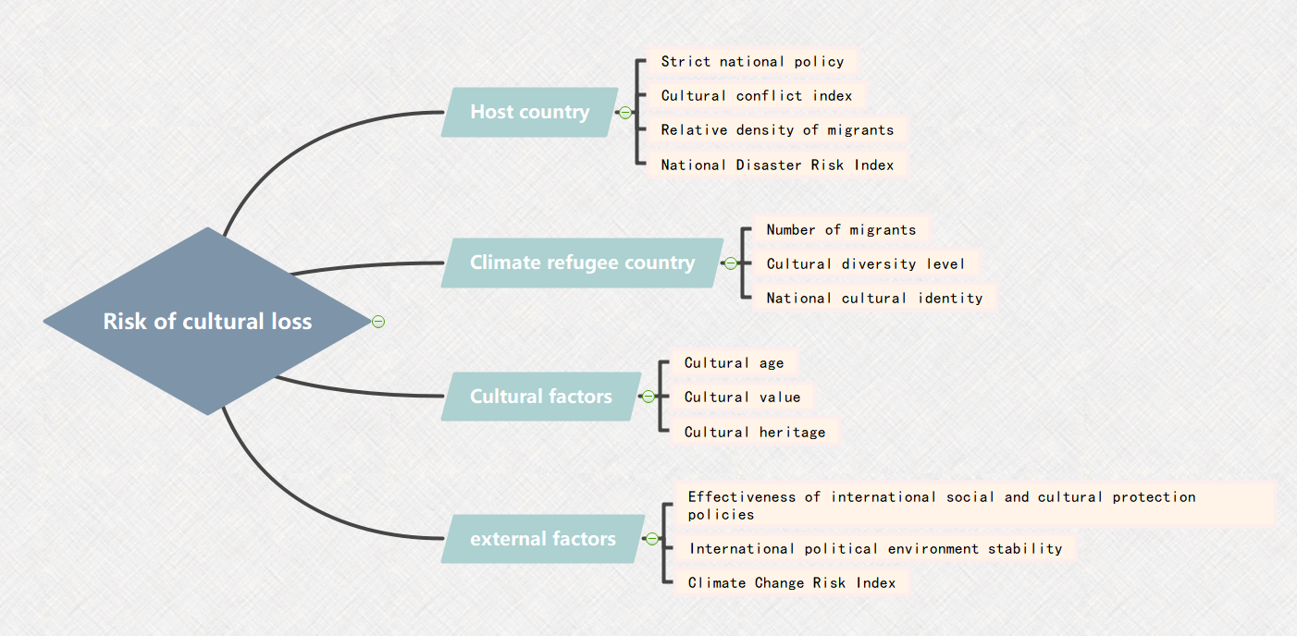

Figure3. Mind mapping of cultural loss
Each of these factors has an impact on the risk of refugee culture loss. We give it a quan-titative standard to facilitate the analysis. The quantitative index units and explanations of each factor are as follows:
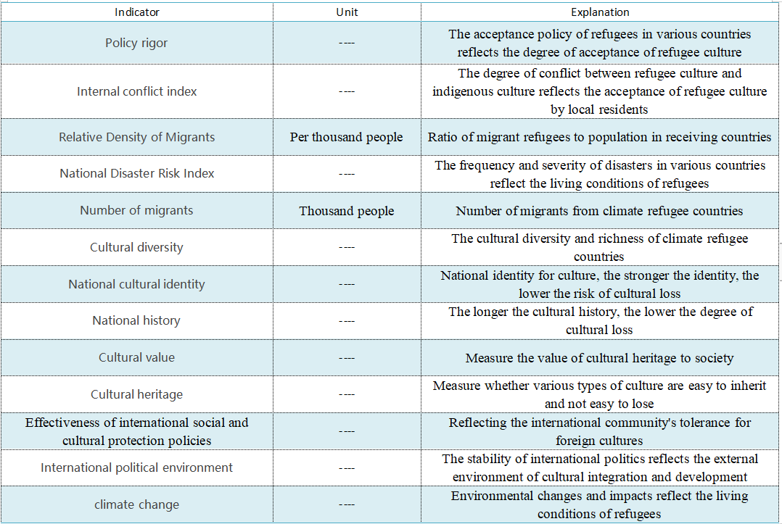
Figure4. Factors and explanations of the risk of cultural loss

After research and comparison, we come to the following four factors that hinder the development of refugees' original culture:

Table2. Data of Some Reasons that Could Cause Cultural Loss on Host Country
Country | NP | CC | NM | RM
United States | 0.80 | 10.5 | 262 | 8.01
Germany | 0.52 | 9.58 | 590 | 71.14
Denmark | 0.65 | 9 | 11 | 18.97
Australia | 0.6 | 9.5 | 30 | 12.00
Japan | 0.7 | 10 | 26 | 2.05
Switzerland | 0.45 | 12 | 51 | 59.86

Based on data from four factors, a pairwise comparison matrix is derived:

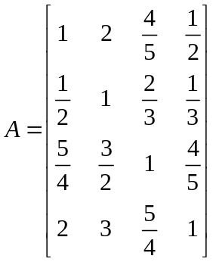

We perform a simple consistency check 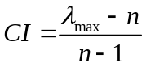(Consistency index CI), 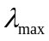is the maximum characteristic root.

A is a four-dimensional matrix. According to the consistency index table, the average consistency index is obtained.

RI = 0.9.
thus
CI=0.0131，CR=CI/RI=0.0147.

The consistency of this matrix is acceptable.
Find the weights of the four indicators as:

For cultural loss, NP and CC are benefit factors, and NM and RM are cost factors.
So for a certain area,risk of cultural loss is:

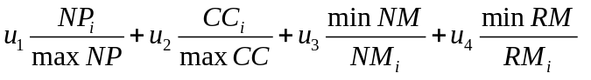

The risk index calculated in this way can be compared with the country risk indexes in the table. For them:

maxNP = 0.80, maxCC = 12, minNM = 11, minRM = 2.05.

Table3. Risk Index of Cultural Loss

Country | United States | Germany | Denmark | Australia | Japan | Switzerland
United States | 0.4484 | 0.2673 | 0.5812 | 0.4333 | 0.8005 | 0.3284

4 Policy Analysis Model
4.1 Proposed Policy
4.1.1 Human Rights

The Office of the United Nations High Commissioner for Refugees (UNHCR) and histori-cally, the Protocol adopted in 1967 only provides rights to persons displaced by politically relevant security issues such as racial or religious persecution.
In terms of human rights, we consider giving EDP similar powers to other UN EDPs.

- The EDP should be given the right to assist the country's residency. As far as housing is concerned, it should be given as preferential treatment as possible. In any case, this treat-ment must not be lower than that enjoyed by ordinary foreigners in the same situation. Such as the establishment of refugee camps.
- The right to work for an EDP is given to the most-favoured-nation treatment enjoyed by a foreign national in the same circumstances with regard to the right of an EDP legally staying in its territory to engage in work in exchange for wages.
- EDP is empowered with respect to education, and EDP should enjoy the same treatment as nationals in primary education. Refugees should be treated as preferentially as possi-ble with regard to education other than primary education, particularly in terms of access to academic research, recognition of foreign schools' certificates, diplomas, and degrees, tuition waiver, and scholarships. This treatment shall not be lower than that enjoyed by ordinary foreigners under the same circumstances. National language training should be provided for domestic EDP.
- EDP's powers in public relief should be accorded medical treatment the same treatment enjoyed by its nationals. Measures such as issuing health cards. Issue a minimum living allowance.
The proposed policies on human rights and references to these policies are shown below:

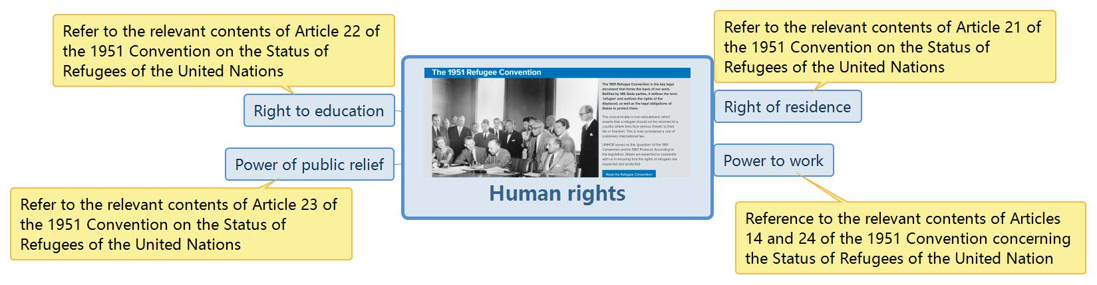

Figure5.Proposed policies on human rights and references

4.1.2 Cultural Protection

As far as the protection of refugee culture is concerned, the rise in sea levels caused by climate issues has led to the displacement of some islanders and even the demise of one country. The culture of languages, music, art, dance, social norms and lifestyle of these islanders is facing huge challenges. Risk of loss. Although displaced residents can preserve some aspects of their culture, cultural loss caused by geographical characteristics is inevitable, and the degree of cultural retention is also closely related to external factors, cultural factors and host country policies. In response to this situation, we propose some proposed policies, hoping to help refugees preserve their unique culture to a greater extent and continue cultural diversity.

- Considering the factors of culture itself, some ancient ways of inheriting culture not only consume manpower and material resources, but also are not conducive to the wide spread of culture. Therefore, improving and expanding the inheritance of culture and encouraging culture to advance with the times can effectively reduce the risk of cultural loss.

From the perspective of the host country, cultural conflicts and collisions between different countries and races are a major source of the risk of cultural loss. From the perspective of cultural protection, promoting the exchange and integration of different cultures and even deriving new cultures is the best way for the two cultures to coexist peacefully, and refugees will find a sense of belonging in the host country. In this regard, there are the following:

- Adopt an inclusive and open attitude and policy towards the culture of refugees, allowing different cultures to exist and develop in the host country
- Relying on new media technologies to promote cultural exchanges and integration be-tween the two parties
- Allow freedom of religious culture and language

The proposed policies on cultural protection and the references that propose them are shown below:


Figure6. Proposed policies on cultural protection and the references

4.2 Model Construction of Potential Impact of Policies

Based on our proposed policy, the potential impact of human rights and cultural protection issues covered by the policy is explored below.
By consulting relevant data and literature, analyze the impact of each policy on refugee hu-man rights and cultural protection. For example, with regard to human rights, we have found the proportion of refugees who can directly consult and receive regular medical treatment be-fore the implementation of the health card measure; compared with the proportion of refugees admitted after the trial of the health card measure, the health card The extent to which their policies affect the human rights of refugees.Other policy impact analysis methods are similar.
Establish such a Bayesian network in accordance with policies.

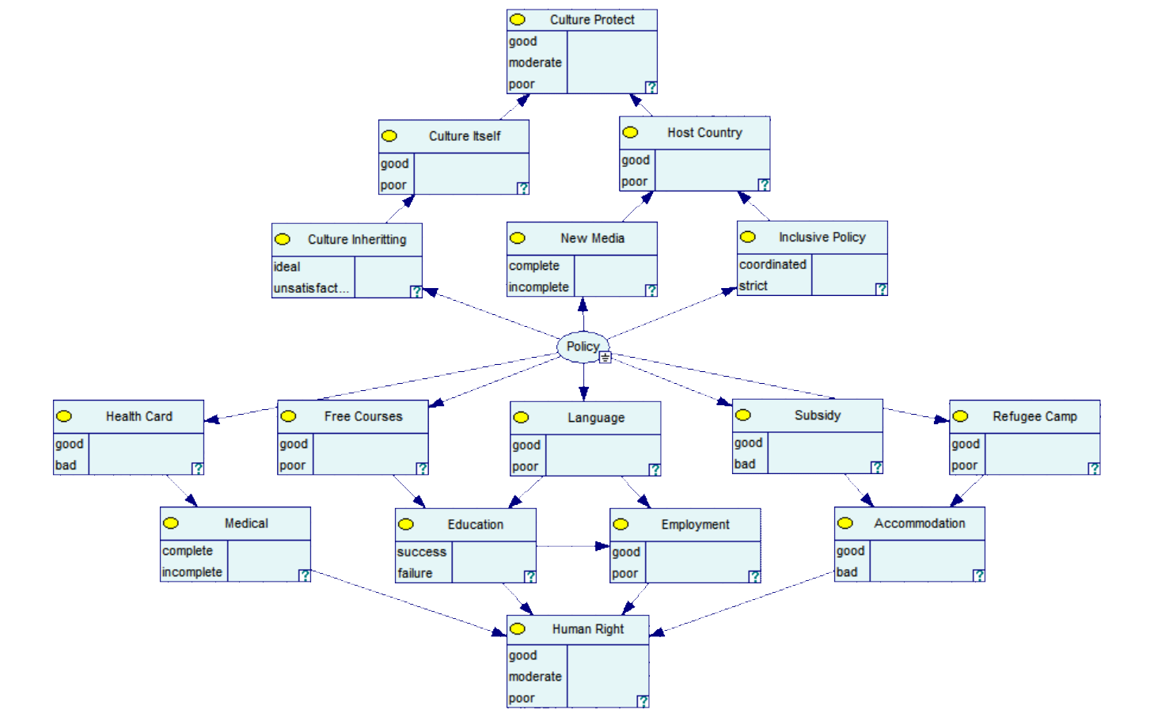
Figure7. Logical Procedure of Bayesian Networks Model

The first to second, second to third order weights have been given in the analysis just now.

The most important is the weighting of the third to fourth order, that is, the impact of four major aspects on the final human rights index. In order to characterize this effect more accu-rately, we first consider the effect on the result when there is only one of four kinds, the pro-bability of good, medium, and poor conditions.
The we need to make the situation more comprehensive, so we add a new column to faci-litate the flexible establishment of weight functions.

We build such a matrix:

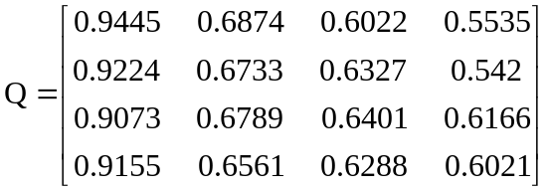

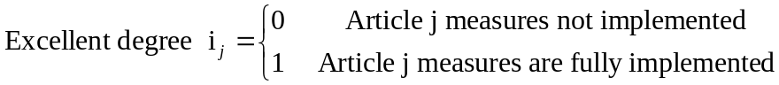

In this way, using the matrix Q, we can define the human rights good index, moderate index, and poor index.
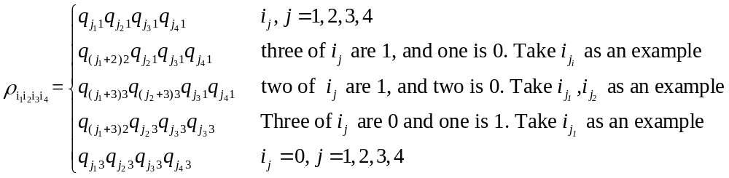

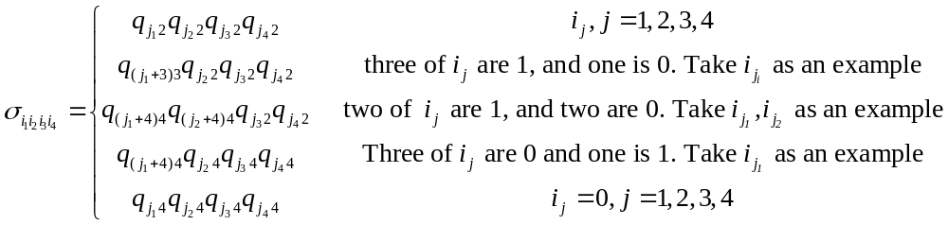

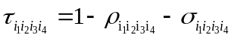

In this way, we get the idealized weights and bring them into our Bayesian network model, that is:

Table4. Human Right Indexes of 16 Conditions of 4 Main Aspects
Human rights index | 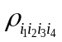 | 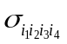 | 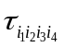
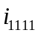 | 0.7237 | 0.2062 | 0.0701
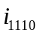 | 0.5186 | 0.2838 | 0.1976
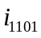 | 0.5415 | 0.2641 | 0.1944
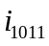 | 0.5282 | 0.2780 | 0.1938
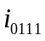 | 0.5267 | 0.2983 | 0.1750
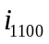 | 0.3881 | 0.1718 | 0.4401
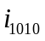 | 0.3409 | 0.1523 | 0.5068
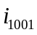 | 0.3502 | 0.1507 | 0.4991
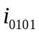 | 0.3256 | 0.1208 | 0.5236
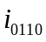 | 0.3169 | 0.1523 | 0.5308
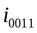 | 0.3844 | 0.1336 | 0.4820
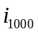 | 0.1751 | 0.1212 | 0.7037
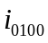 | 0.1632 | 0.1300 | 0.7068
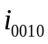 | 0.1627 | 0.1156 | 0.7217
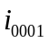 | 0.1600 | 0.1163 | 0.7237
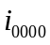 | 0.1534 | 0.1113 | 0.7353

Similarly, cultural protection can be easily derived based on the weight of the culture itself and the receiving country.

Table5. Human Right Indexes of 16 Conditions of 4 Main Aspects
Human rights index | 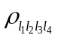 | 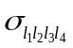 | 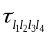
l₁₁ | 0.8911 | 0.0324 | 0.0701
l₁₀ | 0.3504 | 0.2899 | 0.3897
l₀₁ | 0.2533 | 0.296 | 0.4507
l₀₀ | 0.609 | 0.1458 | 0.7933

Now the framework of the entire model is presented. First, let's take a look at the measurement of the model when the policy is not implemented, that is,

as well as

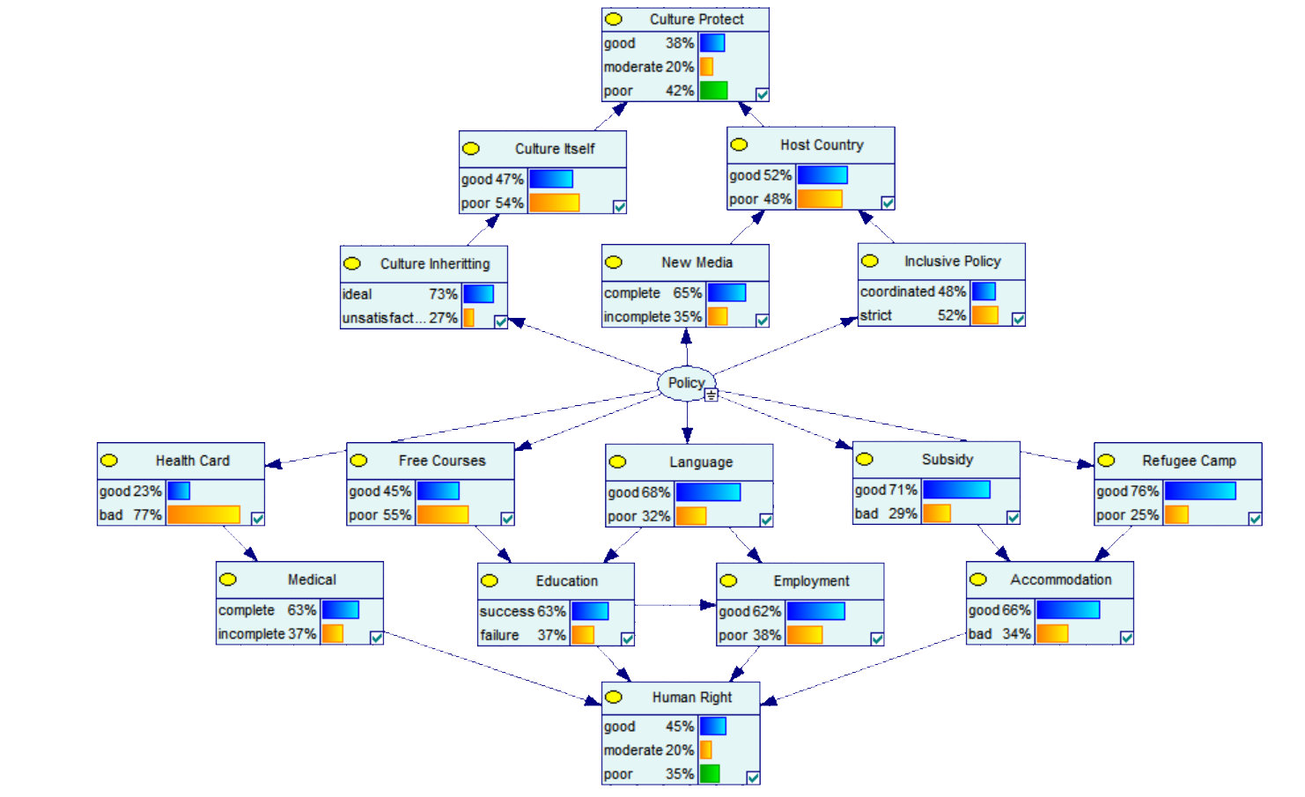
Figure8. Logical Prediction of Bayesian Networks Model while NO Policy carried
Let 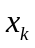 represent the random variable represented by k nodes and 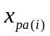 be the parent node of .
Know from the chart：

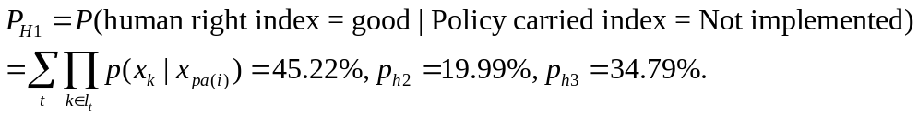
Quantify the weights for the three levels,

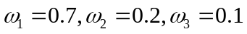
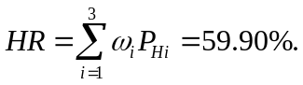

The same calculation process for cultural protection.
The following to measure the effect of policy improvement on each specific measure.

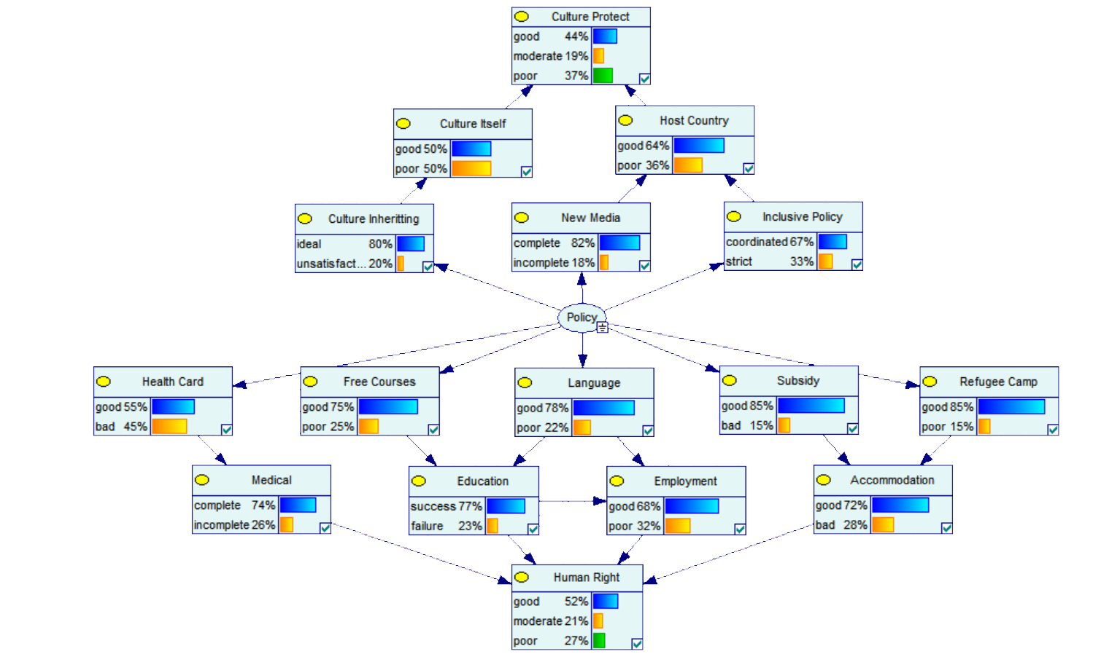
Figure9. Logical Prediction of Bayesian Networks Model AFTER Policy carried
Enter the improved data into the model, and the following table can be obtained from probability calculation and weighted calculation.

Table 6. Potential Impact of Proposed Policy
Potential Impact Index |  | P_{H1}/P_{C1} | P_{H2}/P_{C2} | P_{H3}/P_{C3} | HR/CP
Human rights | Before policy | 0.4522 | 0.1999 | 0.3479 | 0.3913
Human rights | Post-policy | 0.5186 | 0.2148 | 0.2666 | 0.4326
Cultural protection | Before policy | 0.3815 | 0.1963 | 0.4222 | 0.3485
Cultural protection | Post-policy | 0.4410 | 0.1922 | 0.3668 | 0.3838

According to the model above, it can be seen that the proposed policy has played a positive role in promoting human rights and cultural protection.

4.3 Model Optimization

In order to optimize the model in terms of practicality and authenticity, we also need to quantitatively explore the impact of the number of refugees in the host country on the entire model, in other words, how much space the policy has left for the scope of the policy.
We first explore the factors that affect the number of refugees in different countries. Con-sidering that the relatively large contribution of high-polluting countries to global warming and sea level rise leading to the loss of the environment in refugee countries, the carbon emis-sions of different countries need to be considered. In addition, internal factors in receiving EDP countries can also affect refugee numbers.
Taken together, it can be summarized into three aspects and five factors, as shown in the following figure:
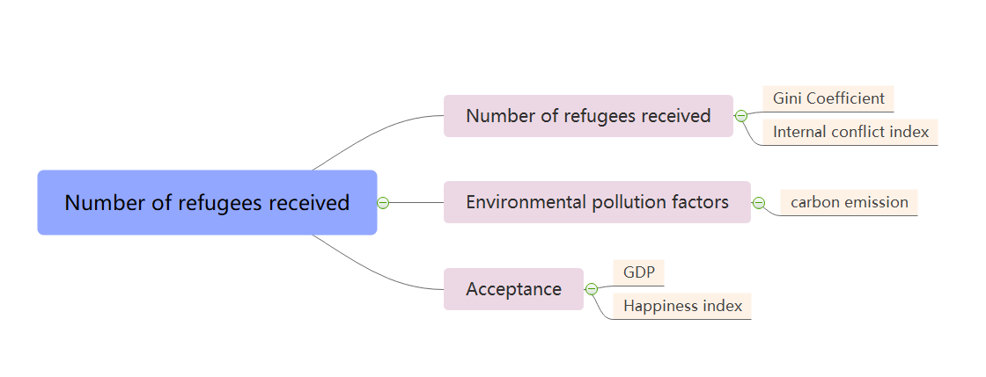
Figure10. Factors affecting the admission of refugees

By adding them to the original network and setting parameters at all levels, you can easily judge the applicability of the model to the different conditions of each country. The influence factors of each of these factors and their general aspects can be obtained in the same way as the previous question, and the specific data are given in the appendix.

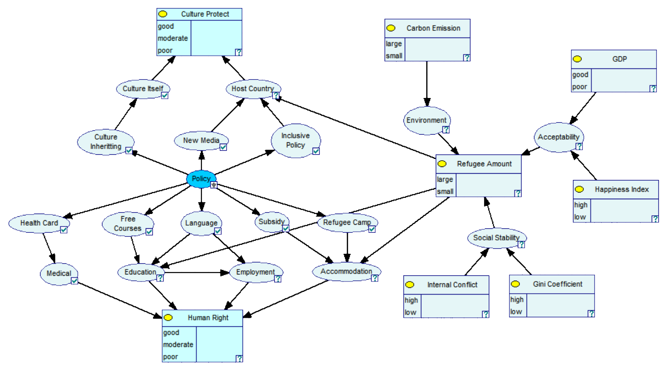
Figure11. Procedure of Improved Model
In view of the relationship between the number of EDPs and the original model, we believe that the three areas most affected are education, accommodation, and host country. Note that this does not mean that the number of EDPs has a direct impact on them. We are discussing and quantifying the effect of policies in the original model on human rights and cultural pro-tection under a specific number of EDPs.
Obviously for human rights, the increase in refugees will inevitably have a negative impact (regardless of the sudden large-scale migration of EDPs), because its available resources are limited. On the contrary, the increase in the number of refugees for cultural protection can play a positive role. From the first question, risk of cultural loss is:

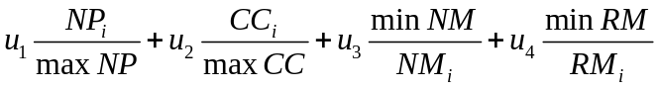

It can be seen that the risk of cultural loss is approximately inversely related to the number of refugees. According to this rule, we assign reasonable weights to the cultural aspects of the receiving country.

Table7. Rates About How Refugee Amounts Influence Original Model
New Media | Inclusive Policy | Refugee Amount | Host Country
New Media | Inclusive Policy | Refugee Amount | Good | Poor
Complete | Coordinated | Large | 0.92 | 0.08
Complete | Coordinated | Small | 0.81 | 0.19
Complete | Strict | Large | 0.68 | 0.32
Complete | Strict | Small | 0.56 | 0.44
Incomplete | Coordinated | Large | 0.55 | 0.45
Incomplete | Coordinated | Small | 0.34 | 0.66
Incomplete | Strict | Large | 0.35 | 0.65
Incomplete | Strict | Small | 0.15 | 0.85

In the same way, the weakening benefits of refugee numbers to education and accom-modation can be obtained, and the data can be brought back into the model for calculation.
Consider how much HR and CR can be improved by this model under the same policy in Germany, Denmark and China.

Table8. Affects of the Improved Model in Various Countries
Country | HR |  | CR
Country | Before | After | Before | After
Germany | 0.3652 | 0.4037 | 0.3877 | 0.4215
Denmark | 0.3426 | 0.3557 | 0.3606 | 0.3801
China | 0.4253 | 0.4465 | 0.4690 | 0.4921

It can be seen that the difference in the number of refugees that can be accepted in different countries does lead to different models.

4.4 The Importance of Policy

4.4.1 Human Rights

United Nations High Commissioner for Refugees (UNHCR) and Historically, 1951 Con-vention Relating to the Status of Refugees provides a definition of refugee: a person who has a legitimate reason to fear to remain outside of his country because of race, religion, nation-ality, belonging to a social group, or has some political opinion, and cannot or is unwilling to do so, a person protected by that country or a person who does not have a nationality and is reluctant to return to the country now or because of the above-mentioned fear or the above-mentioned matter staying outside of the country where he previously resided.
This definition is focused on politically relevant security issues (such as racial or religious persecution) to provide rights to displaced persons. From this we can see that the rights of refugees such as EDP have not been generally recognized internationally. So our proposed policy provides ideas for solving EDP problems in the future.

- Based on our Bayesian model, we can see that the improvement of human rights pro-tection for EDP in human rights is obvious. Especially for Germany, which has a large number of refugees, the establishment and improvement of human rights policies can increase the human rights index from 36.52% to 40.37%, and other countries with less crisis situations can also get about 2.3%.
- To make the reader more receptive to this result, we have added some data to ensure that the reader can understand the importance of our model implementation.
- In terms of education, we can see that the education level of EDP children has not decreased or even slightly improved due to the policies we have implemented.
- In terms of employment, we can see that finding a job is not difficult for a highly educated EDP.
- The improvement in accommodation is particularly obvious, basically all EDPs can live in the immigrant country.
- In terms of cultural protection, most of the cultures that are not related to geographical location can be better protected.
- As for the social security system and The improvement of medical level is not ob-vious, which is related to the medical level and financial status of the immigrant country.
In conclusion, we can see the importance of implementing the proposed policy through the protection of human rights in EDP.

4.4.2 Cultural Protection

Regarding cultural protection, the cultural situation of these island nations' languages, mu-sic, art, dance, social norms and lifestyles is not optimistic. Although displaced residents can preserve some aspects of their culture, cultural loss caused by geographical characteristics is inevitable, and the preservation of culture is also restricted to a certain extent by host count-ries and resistance to local residents. Risk of cultural loss. This can be seen in the relevant models for the calculation of the risk of cultural loss.
In particular, the risk in the United States and Japan relative to German EDP has even doubled, and Japan has exceeded 80% under many adverse conditions.

According to the results of the prediction calculation of the evaluation model after the im-plementation of the policy, we see in Figure12. that after the implementation of the policy, the probability that the degree of cultural protection is excellent has increased from 38.15% to 44.10%. Even if the policy is blocked during implementation to some extent (such as the number of EDPs), it can still increase by 1.3% to 2.1%.
This shows that our policies and models are playing an important role in mitigating and improving the increasingly serious EDP situation.

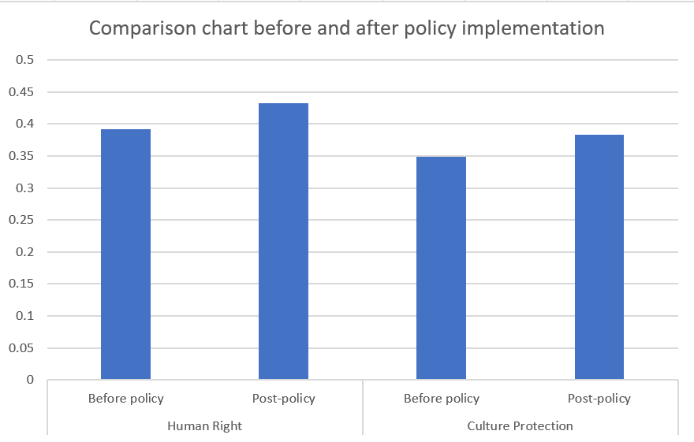

Figure12. Comparison chart before and after policy implementation

4.4.3 EDP-Receiving Country
In implementing our proposed policy, it is impossible not to consider the impact of the im-migrant country, first of all the gains and losses caused by the introduction of new culture and art. Based on our model, there has been a significant improvement in cultural protection from 0.3485 to 0.3838, and considering the loose cultural policy for immigrants in our proposed policy, we chose to draw on the results of the social integration of British immigrants, which can fit our policy influence very well. The reason why the development of British culture is still strong today It is precisely because it can continuously absorb the factors of different cul-tures, so that it is constantly enriched and renewed. Therefore, we believe that the benefits of new culture and art are greater than the losses.
- Regarding the impact of EDP children on the immigrant country, comprehensively our model and the study of compulsory education in Europe and the United States based on the paper can find the net effect of immigrant students on local students, that is, the direct endogenous impact is not large, Approximately nothing.
- Regarding the impact of public medical pressure in immigrant countries, combining our model and the comparison of US medical treatment measures for refugee and illegal immigrants, we conclude that the changes to the medical union system in immigrant countries before and after implementing our proposed policy are not very significant. Large, it has little impact on the economic resource allocation of the immigrant countries.
- Regarding political conflicts, because EDP may come from different countries, different geographical environments will definitely lead to differences in the living environment, cultural characteristics, and even the political system of the emigrated country. When EDP enters the immigrant country, it will naturally raise political needs. Combining the history of France's acceptance of refugees, it can be seen that after implementing our proposed policy, although refugees may have a certain level of political conflict with the government, it will not exceed the status quo in France, that is, refugees will still integ-rate into the immigrant countries. The political stability of the immigrant countries will have some impact but will not have serious consequences.

4.5 Sensitivity Test

We perform a sensitivity analysis by altering parameters in our model. For each parameter, we vary it from half to 1.2 times its value. We also vary the weight of influence caused by each policy from 0.85 to 1.25 its value. It indicates that our model only rise about one order of magnitude when less than 3 parameters change, which suggests its stability. However, when there exists various changes of more than 3 parameters, the model tends to have a little larger change.

4.6 Strengths and Weaknesses

Strengths:

    - Multiple inputs and outputs make the model easy to adjust the influencing factors accor-ding to the specific situation.

    - Data changes of weights and policies are easily adjusted in the model, that is, they have a certain universality.

Weaknesses:
- Lack of specific quantitative discussions on cyclical changes in temperature.
- There is no difference in the measurement of parameters and weights in different count-ries in policy forecasts.
- The model has high requirements for variable accuracy, and requires large, comprehen-sive and timely data updates.

References:

[1] GDP, Gini coefficient, carbon emissions per capita:https://data.worldbank.org.cn
[2] Carbon Dioxide，Global Temperature，Sea Level:https://climate.nasa.gov/vital-signs/carbon-dioxide/
[3] Refugees over the years:https://www.unhcr.org/statistical-yearbooks.html
[4] Convention concerning the Status of Refugees:
https://www.un.org/zh/documents/treaty/files/OHCHR-1951.shtml
[5] Tao Xie.2006. On the Social Integration of European Immigrants. Chinese picture classification number: C924.1 Document identification code: A Article number: 1007-0672 (2007) 02- 0029- 04
[6] WenWen Zhang.2017.The impact of immigrant students on the education of local students in compulsory education : New progress in foreign research. Chinese picture classification number: G40-052 Document mark code: A Article number: 1674-2311 (2017) 2-0047-07
[7] Frank Bierman,Ingrid Boa.2008.Global Framework Protocol for the Protection of Climate Refugees. From the American Environmental Magazine November / December 2008
[8] Refugees in Europe: http://www.cssn.cn
[9] ZhengYu Wang.2013.Research on Climate Change and Environmental Refugee Guarantee Mechanism:Normative System of International Law and Practice in European and American Countries. European and American Studies, Volume 43, Issue 1 , 149-212© European Research Institute, Academia Sinicahttp://euramerica.org
[10] LiJuan Gao,WenMian Huo,LiBao Dou.2008. Research on Environmental Refugees. Chinese picture classification number X820.3 Document identification code A Article number 0517-6611 (2008) 04-01519-02
[11] HuiPing Wu,Lang Zheng.2011. Comparison of immigration integration policies in European countries. Chinese picture classification number: F112 2 Document identification code: A Article number: 1637 324X (2011) 01 38 43 06
[12] Qin Yang,Hui Xu.2017. Status and New Trends of Immigrant Education in Germany. Chinese picture classification number: G649 Document identification code: A Article number: 1673-9841 (2017) 02-095-05
[13] YongLin Bao.2002. Crisis of Multiculturalism under the Impact of Refugee Waves in Europe. Chinese picture classification number | D815. 6

Sincerely,
Team #2020016

